

**ACS712**

Fully Integrated, Hall Effect-Based Linear Current Sensor with 2.1 kVRMS Voltage Isolation and a Low-Resistance Current Conductor

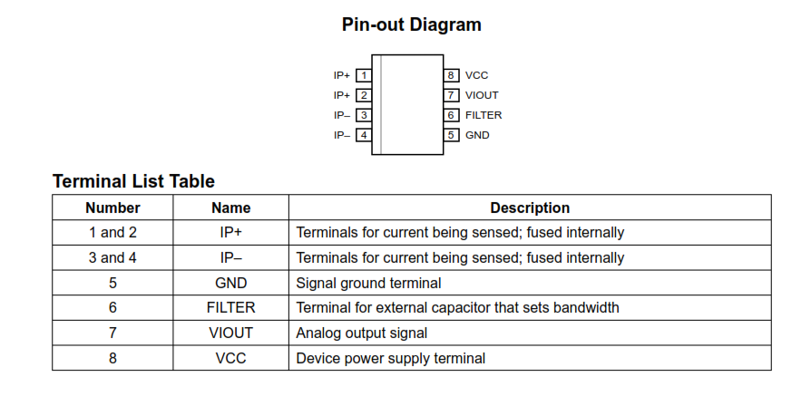

**Features**

▪ Low-noise analog signal path

▪ Device bandwidth is set via the new FILTER pin

▪ 5 μs output rise time in response to step input current

▪ 80 kHz bandwidth

▪ Total output error 1.5% at TA = 25°C

▪ Small footprint, low-profile SOIC8 package

▪ 1.2 mΩ internal conductor resistance

▪ 2.1 kVRMS minimum isolation voltage from pins 1-4 to pins 5-8

▪ 5.0 V, single supply operation

▪ 66 to 185 mV/A output sensitivity

▪ Output voltage proportional to AC or DC currents

▪ Factory-trimmed for accuracy

▪ Extremely stable output offset voltage

▪ Nearly zero magnetic hysteresis

▪ Ratiometric output from supply voltage

**Description**

The device consists of a precise, low-offset, linear Hall sensor circuit with a copper conduction path located near the surface of the die. Applied current flowing through this copper conduction path generates a magnetic field which is sensed by the integrated Hall IC and converted into a proportional voltage

FUNCTIONAL BLOCK DIAGRAM

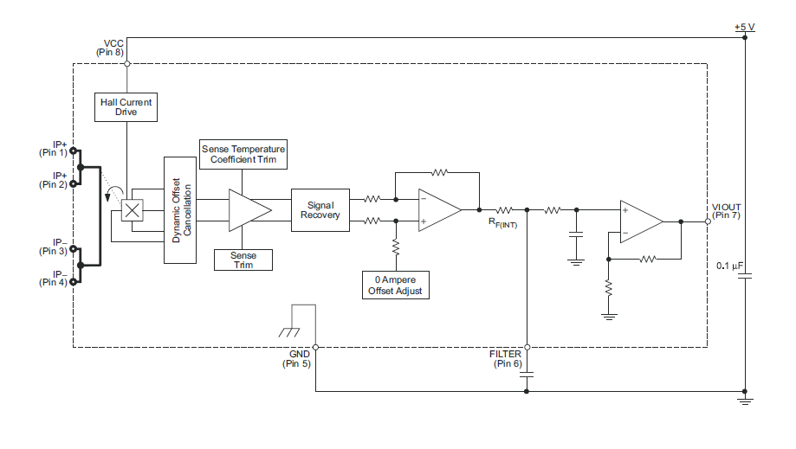

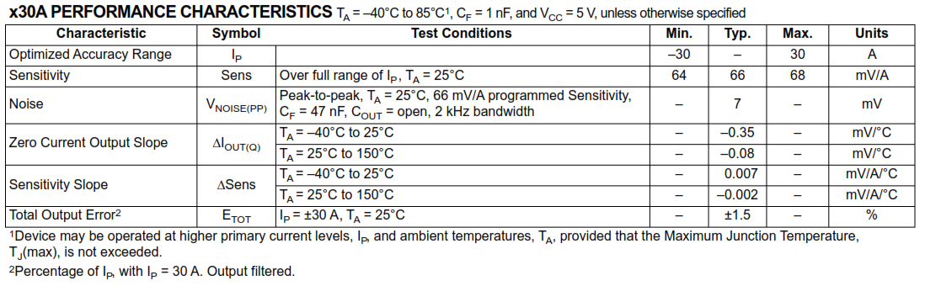

**ADS1115**

ADS111x Ultra-Small, Low-Power, I2C-Compatible, 860SPS, 16-Bit ADCs with Internal Reference, Oscillator, and Programmable Comparator

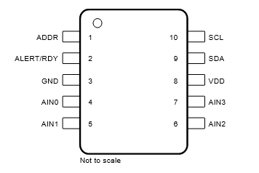

ADS1115 PIN CONFIGURATION

|  |  |  |  |  |  |
| --- | --- | --- | --- | --- | --- |
| **PIN** | | | |  |  |
| **NAME** | **ADS1113** | **ADS1114** | **ADS1115** | **TYPE** | **DESCRIPTION**(1) |
| ADDR | 1 | 1 | 1 | Digital input | I2C target address select |
| AIN0 | 4 | 4 | 4 | Analog input | Analog input 0 |
| AIN1 | 5 | 5 | 5 | Analog input | Analog input 1 |
| AIN2 | — | — | 6 | Analog input | Analog input 2 (ADS1115 only) |
| AIN3 | — | — | 7 | Analog input | Analog input 3 (ADS1115 only) |
| ALERT/RDY | — | 2 | 2 | Digital output | Comparator output or conversion ready (ADS1114 and ADS1115 only). Open-drain output. Connect to VDD using a pullup resistor. |
| GND | 3 | 3 | 3 | Analog | Ground |
| NC | 2, 6, 7 | 6, 7 | — | — | No connect. Leave the pin floating or connect to GND. |
| SCL | 10 | 10 | 10 | Digital input | Serial clock input. Connect to VDD using a pullup resistor. |
| SDA | 9 | 9 | 9 | Digital I/O | Serial data input and output. Connect to VDD using a pullup resistor. |
| VDD | 8 | 8 | 8 | Analog | Power supply. Connect a 0.1μF, power-supply decoupling capacitor to GND. |

**Features**

• Ultra-small packages:

– X2QFN: 2mm × 1.5mm × 0.4mm

– SOT: 2.9mm × 2.8mm × 0.6mm

• Wide supply range: 2.0V to 5.5V

• Low current consumption: 150μA (continuous-conversion mode)

• Programmable data rate:8SPS to 860SPS

• Single-cycle settling

• Internal low-drift voltage reference

• Internal oscillator

• I2C interface: four pin-selectable addresses

• Operating temperature range: – 40°C to +125°C

• Family of devices:

– ADS1113: one single-ended (SE) or differential (DE) input

– ADS1114: one single-ended or differential input with comparator and PGA

– ADS1115: four single-ended or two differential inputs with comparator and PGA

**Description**

The ADS1115 also in corporate a programmable gain amplifier (PGA) and a digital comparator. These features, along with a wide operating supply range, are useful for power- and space-constrained, sensor measurement applications.

The ADS111x devices perform conversions at data rates of up to 860 samples per second (SPS). The PGA offers input ranges from ±256mV to ±6.144V, allowing precise large- and small-signal measurements. The ADS1115 features an input multiplexer (MUX) that allows two differential or four single-ended input measurements. Use the digital comparator in the ADS1114 and ADS1115 for under voltage and overvoltage detection

FUNCTIONAL BLOCK DIAGRAM

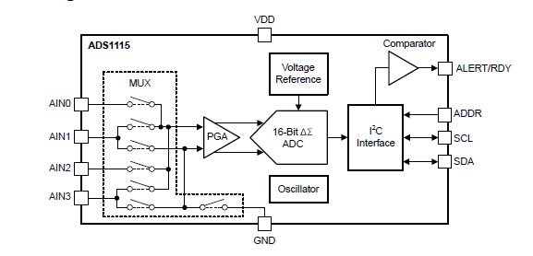

DATA FORMAT

The ADS111x provide 16 bits of data in binary 2's-complement format. A positive full-scale (+FS) input produces an output code of 7FFFh and a negative full-scale (–FS) input produces an output code of 8000h. The output clips at these codes for signals that exceed full-scale

**TABLE . Input Signal Versus Ideal Output Code**

|  |  |
| --- | --- |
| **INPUT SIGNAL VIN = (VAINP – VAINN)** | **IDEAL OUTPUT CODE(1)** (1) |
| ≥ +FS (215 – 1)/215 | 7FFFh |
| +FS/215 | 0001h |
| 0 | 0000h |
| –FS/215 | FFFFh |
| ≤ –FS | 8000h |

RASPBERRY PI 4

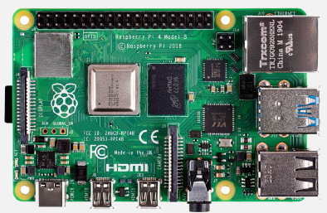 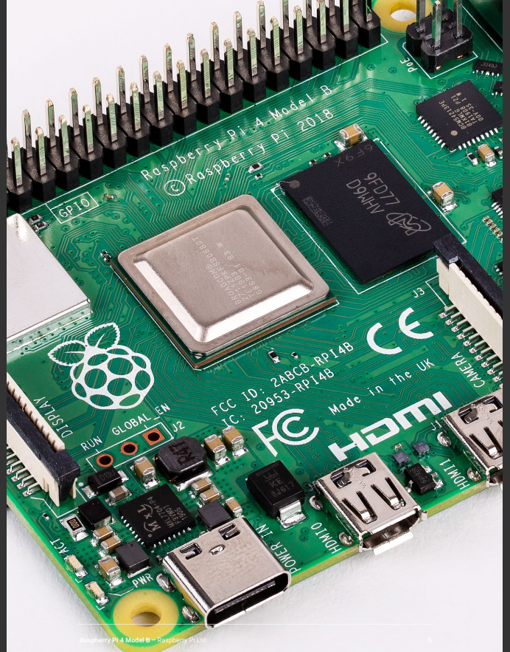

**Features**

Raspberry Pi 4 Model B features a high-performance 64-bit quad-core processor, dual-display support at resolutions up to 4K via a pair of micro HDMI ports, hardware video decode at up to 4Kp60, up to 8GB of RAM, dual-band 2.4/5.0 GHz wireless LAN, Bluetooth 5.0, Gigabit Ethernet, USB 3.0, and PoE capability (via a separate PoE HAT add-on). For the end user, Raspberry Pi 4 Model B provides desktop performance comparable to entry-level x86 PC systems

SPECIFICATIONS

**Processor:** Broadcom BCM2711, quad-core Cortex-A72 (ARM v8) 64-bit

SoC @ 1.5GHz

**Memory:** 1GB, 2GB, 4GB or 8GB LPDDR4 (depending on model) with on-die ECC

**Connectivity:** • 2.4 GHz and 5.0 GHz IEEE 802.11b/g/n/ac wireless LAN, Bluetooth 5.0, BLE

• Gigabit Ethernet

• 2 × USB 3.0 ports

• 2 × USB 2.0 ports.

**GPIO:** Standard 40-pin GPIO header(fully backwards-compatible with previous boards)

**Video & sound:** • 2 × micro HDMI ports (up to 4Kp60 supported)

• 2-lane MIPI DSI display port

• 2-lane MIPI CSI camera port

• 4-pole stereo audio and composite video port

**Multimedia:** H.265 (4Kp60 decode); H.264 (1080p60 decode, 1080p30 encode); OpenGL ES, 3.0 graphics

**SD card support:** Micro SD card slot for loading operating system and data storage

**Input power:** • 5V DC via USB-C connector (minimum 3A1)

• 5V DC via GPIO header (minimum 3A1)

• Power over Ethernet (PoE)–enabled (requires separate PoE HAT)

**Environment:** Operating temperature 0–50ºC

**Current measurement from Sensor:**

The part no which is used our project is ACS712ELCTR-20A-T

* Scale factor is 100mV/A
* Measurement current range is -20A to +20A.

When there is no load, no current flows from the sensor. The sensor out is 2.5V

If load is there, sensor out will varies with load current. The sensor voltage generates as per below equation.

Vsensor(V) = I (A) x Scale factor (mV/A) +2.5V

The current , I(A)= (Vsensor - 2.5)/ Scale factor

Eg: Considered bulb is a load , if there is no current flows from the bulb

The current is I= (2.5-2.5)/0.1=0A

When current flows from the bulb and sensor out voltage is generated. Let us assume that the sensor out is 2.55V

The current flow from bulb is

I = (2.55-2.5) /0.1

=0.05V/0.1

I = 0.5A

Similarly, the load current and sensor voltage will be generated as per table

|  |  |  |
| --- | --- | --- |
| Sl no | Sensor voltage(V) | Load current(A) |
| 1 | 2.5 | 0 |
| 2 | 2.55 | 0.5 |
| 3 | 2.6 | 1 |
| 4 | 2.65 | 1.5 |
| 5 | 2.7 | 2 |
| 6 | 2.8 | 3 |
| 7 | 2.9 | 4 |
| 8 | 3.0 | 5 |
| 9 | 3.1 | 6 |
| 10 | 3.2 | 7 |
| 11 | 3.3 | 8 |
| 12 | 3.4 | 9 |
| 13 | 3.5 | 10 |
| 14 | 3.6 | 11 |
| 15 | 3.7 | 12 |
| 16 | 3.8 | 13 |
| 17 | 3.9 | 14 |
| 18 | 4.0 | 15 |
| 19 | 4.1 | 16 |
| 20 | 4.2 | 17 |
| 21 | 4.3 | 18 |
| 22 | 4.4 | 19 |
| 23 | 4.5 | 20 |

**Calculation for energy:**

* P(W)= Vac (V)x load current (A)

Vac=230V and load current is measured from sensor.

P(W)=230 x load current

Power in killo watt = P/1000

If load current is recorded for 1 second ,the energy is = P(W)x1 second

so, energy for 1hour is P(W)x3600 seconds

Energy ( Killo Watt hr) = P(KW) x time(s) / 3600

1KWH =1unit

Energy(units)= P(KW) x time(s) / 3600

**The following steps to be added in the software for measuring the energy of home for Smart energy meter**

**After reading from ADC**

Vsensor =ADCout

I_current = (Vsensor - 2.5)/ 0.1

Power_kw = (230 x I_current)/1000

Energy_units= Power_kw x time_seconds / 3600

This equations are to be runned continuously every one second